Title or Task: |   

Description:

Files Required
Suitable for Classes: | AIT • Multimedia • Cert II IT • Cert II Bus
Area: | Technology & Enterprise
Teacher: | Mr Peter Faulks

Timeline

Date Due:
Task Brief: | In class lesson

Outcomes:

SOLUTIONS

See completed page
http://peterfaulks.net/Teaching/Student_Compendium/SC007_Church.htm
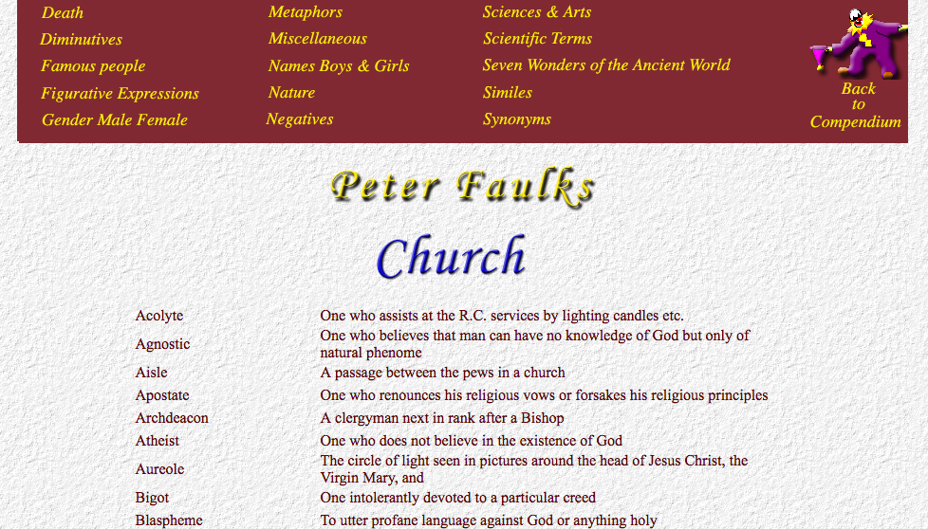

WORDS PERTAINING TO THE CHURCH
The district under the jurisdiction of a bishop | diocese
The principal church in the diocese | cathedral
A passage between the pews in a church | aisle
One who has charge of a church building | sexton
One who leads people to their seats in a church | verger
The money given by the congregation at a church service | offertory
The ceremony at which a man takes Holy Orders and becomes a priest | ordination
A chapel or vault beneath a church usually used for the burial of the dead | crypt
A letter from the Pope to Roman Catholics all
over the world | encyclical
A room attached to the church in which vestments are kept and in which church officials meet | vestry
The residence of a priest or minister or vicar | presbytery, manse, vicarage, rectory
One who sings in the choir | chorister
A reading desk from which the scriptures are read | lectern
The stand from which a preacher delivers sermons | pulpit
A Bishop's staff | crosier
A Bishop's cap | mitre
The garments of parsons and choristers | vestments
A long loose gown worn by priests and choristers | cassock
A loose white vestment with full sleeves worn over the cassock | surplice
A vestment like a surplice worn by bishops | rochet
A cloak-like vestment worn by priests at processions or solemn ceremonies | cope
The cup used in the Eucharist | chalice
The priest officiating at the Holy Communion | celebrant
A rich covering borne over a priest in procession | canopy
The body of ministers ordained for the work in the Christian church | clergy
The people, as distinct from the clergy | laity
A council of clergymen | synod
The vessel or basin containing water for baptism | font
The Head of a Cathedral | Dean
A clergyman next in rank after a Bishop | Archdeacon
One in the lowest degree of Holy orders in the Anglican Church | Deacon
A Clergyman assigned to a regiment, a warship, prison or public institution | chaplain
The circle of light seen in pictures around the head of Jesus Christ, the Virgin Mary, and the Saints | aureole
One who goes to heathen countries to spread the Gospel of Christ | missionary
Morning service of the Anglican Church | matins
Evening service | vespers, evensong
One who does not believe in the existence of God | atheist
One who believes that man can have no knowledge of God but only of natural phenomena | agnostic
One who renounces his religious vows or forsakes his religious principles | apostate
One who is converted from one religion to another | proselyte
One who believes in a single God, e.g. a Christian | monotheist
One who believes in many Gods | polytheist
One intolerantly devoted to a particular creed | bigot
To utter profane language against God or anything holy | blaspheme
Holding opinions contrary to the true doctrine of the church so as to cause a division | heresy
Violating or profaning religious things | sacrilege
A breaker of church images or ornaments | iconoclast
The central or main part of a church | nave
The eastern end of a church | chancel
A portion of a large church or public institution set apart with an altar of its own where services can be held tor a small number of people | chapel
One who assists at the R.C. services by lighting candles etc. | acolyte
A vessel for burning incense | censer
The salary of a clergyman | stipend
The method of administering Holy Communion in both kinds by dipping the bread into the wine | intinction
The land furnishing part of the church revenue | glebe

Save the work



